**Accelerating tilapia sector development in Ghana: Insights from the census of tilapia farmers in 4 major-producing regions**

# 1. Introduction

Over the past decade, Ghana’s tilapia farming has experienced tremendous growth in production, contributing to improved incomes for the industry and animal protein for consumers (Ragasa et al. 2018). Research found the recent growth in tilapia farming in Ghana is largely due to four factors: (i) an improved local Akosombo strain developed and released in 2005, (ii) the government’s policy support initiatives, (iii) improved management practices and technologies at hatcheries and production levels, and finally (iv) availability of high-quality feeds locally (Ragasa et al. 2018). However, fish diseases (e.g., *Streptococcus* bacteria in 2014 and Tilapia Lake Virus [TiLV] in 2018), likely caused by poor management practices, seasonal poor water quality, and illegal imports of foreign Tilapia strains, are causing high mortalities of tilapia in some sections of Lake Volta (according to key informants’ interviews).

To build upon this growth and emerging challenges, international and local research institutes have partnered with private hatcheries and the government’s Fisheries Commission to launch a new project aimed at improving tilapia seed. Titled, **“Accelerating aquaculture development in Ghana through sustainable Nile Tilapia seed production and dissemination,”** TiSeed in short, the project was launched on February 19, 2019.[1] The overall project seeks to improve productivity and profitability of tilapia cage and pond farming in Ghana. The 3-year project, which runs from 2019 to 2022, focuses on tilapia seed improvement and is being implemented by a consortium of international and local research institutes, led by the International Food Policy Research Institute (IFPRI), supported by the CSIR-Water Research Institute (CSIR-WRI), KIT Royal Tropical Institute in the Netherlands, and WorldFish. Other partners are Fisheries Commission (a government institution) and two private hatcheries (S-HOINT Ltd. and Crystal Lake Ltd.). The project has multiple components including diagnostic study, capacity assessments of actors, household surveys, characterization of fingerling and tilapia genetic make-up and productivity performance via on-farm trials; interventions design via randomized control trials, and impact evaluation.

This paper summarizes the (baseline) data collected from the census of active small tilapia farmers in four major producing regions: Ashanti, Brong Ahafo, Eastern and Volta. The latter two regions are the major cage tilapia producers, and also where the medium and large cage farmers around Lake Volta are located. The former two regions are where most pond farmers are located. Small farmers are defined to be producing less than 50 metric tonnes per year, which is consistent with FC and WRI definitions.[2]

The rest of the paper is structured as follows. Section 2 presents the methods and survey details. Section 3 represents the descriptive analysis of the household data. Section 4 presents some of the major trends in the data and summary of the major messages from the descriptive analysis.

# 2. Methodology

This paper describes the data from the household survey led by the International Food Policy Research Institute (IFPRI) and Water Research Institute (WRI), implemented by FMMS survey firm on May-June 2019. The survey covers all active small tilapia farmers in the four focus regions: Ashanti, Brong Ahafo, Eastern and Volta.

The survey teams started with the list from the Fisheries Commission (FC), however it was not updated. The survey teams adapted several ways to update the list including working with the FC zonal officers (who are the frontline extension workers on aquaculture and fisheries), WRI researchers, village leaders, and farmer associations and groups. The data is the best effort from the survey team to update the list of all active small tilapia farmers. A total of 479 active small tilapia farmers are identified.

Many in the original FC list are inactive (or those that did not farm for the last 2 years). We included a sample of these farmers (a total of 124 farmers) who indicated that they are interested in returning to fish farming, to get a sense of the challenges they faced. It is not meant to be exhaustive, but only a sample of those inactive farmers but are interested in returning to fish farming. Due to the difficulty of retracing all the inactive farmers, it is hard to tell the exact number of inactive ones or where the largest number of farmers that become inactive per region; however, it seems to indicate that farmers become inactive almost in similar trends or proportions across all regions. Figure 1 shows a snapshot of the small grow-out farmers surveyed in the four focus regions, and those with both hatcheries and grow-out farms and hatcheries based on the IFPRI/WRI assessment in July 2019.[3]

Figure 1. Location of tilapia farmers and hatcheries in 4 focus regions

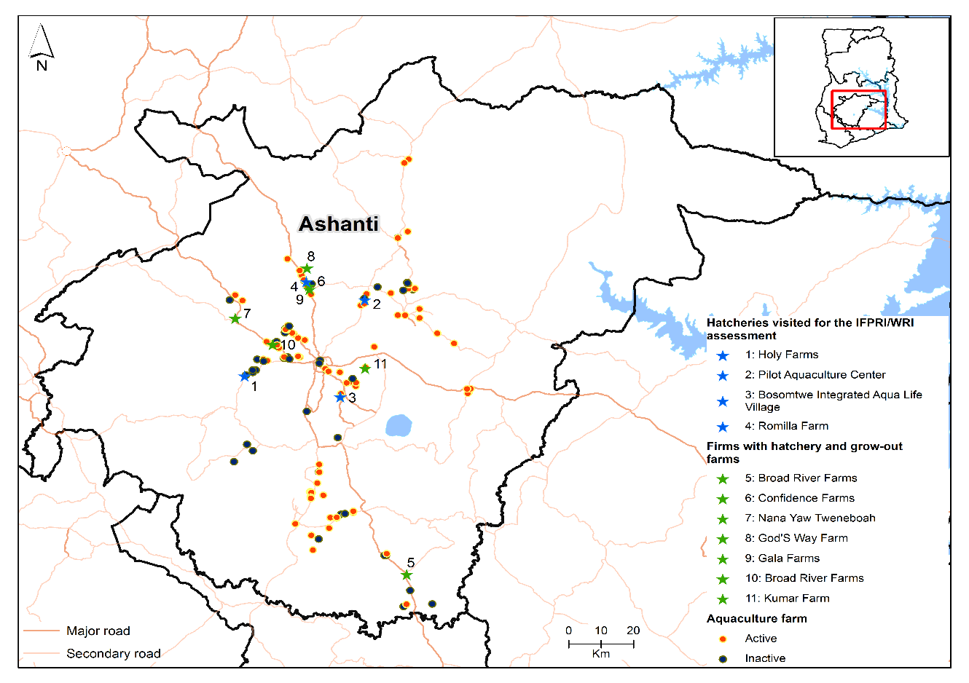

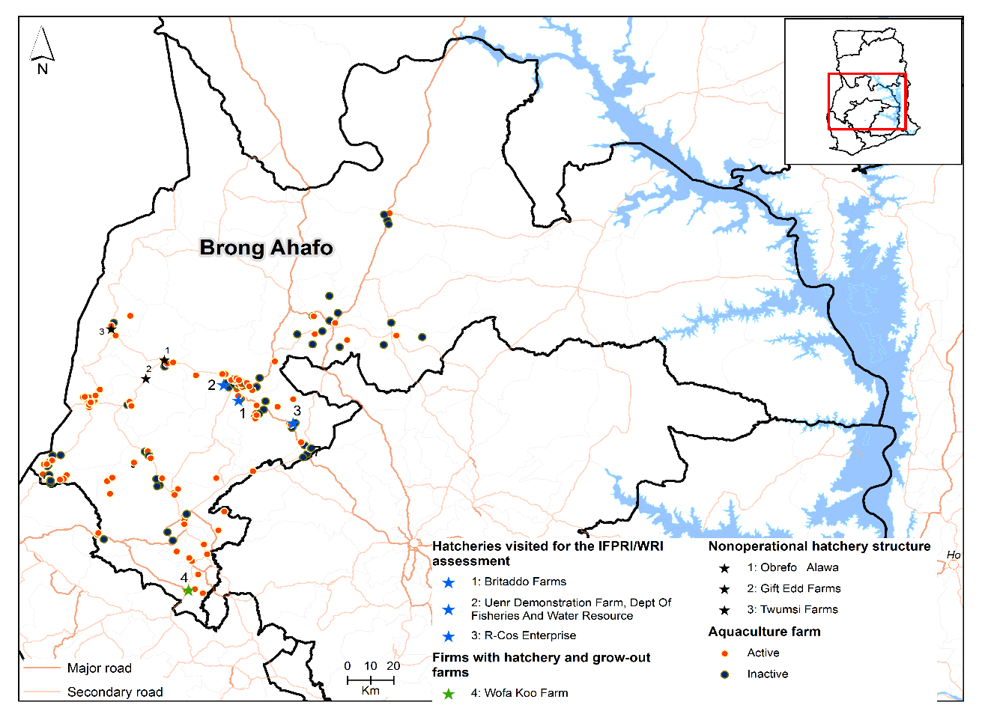

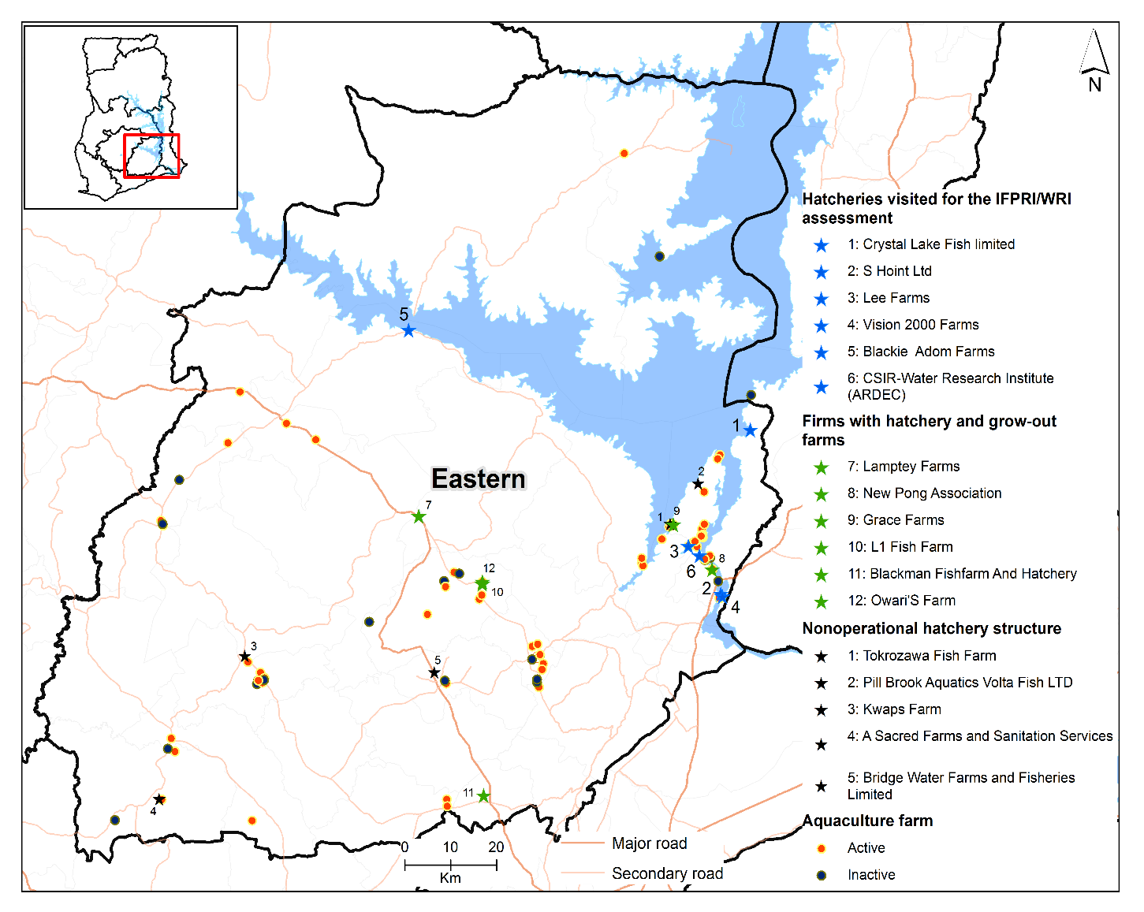

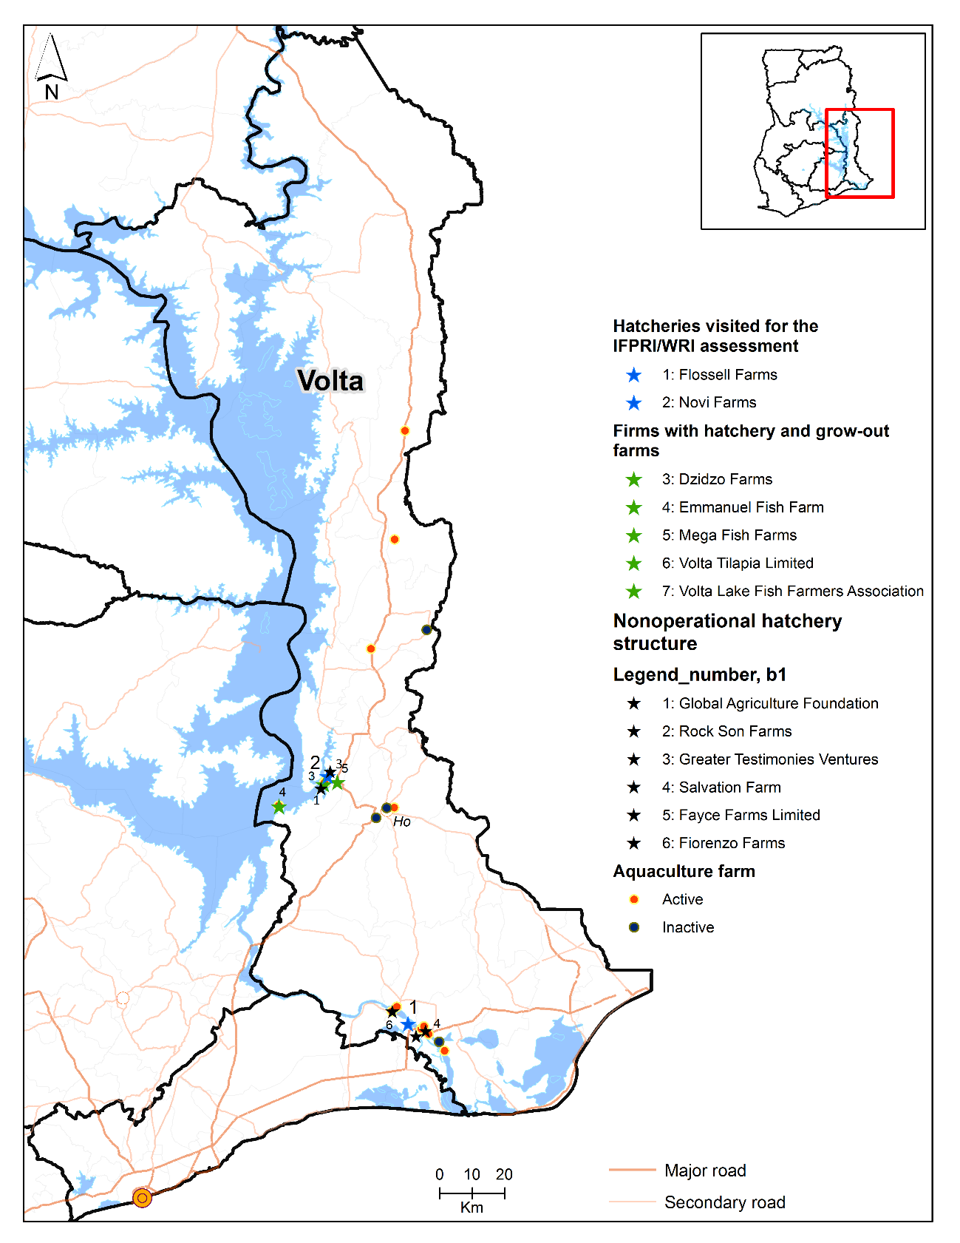

Source: IFPRI/WRI household survey and hatchery assessment (2019). Note: Holy Farms and Romilla Farm (in Ashanti); Britaddo Farms, UENR, and R-Cos Enterprise (in Brong-Ahafo); Lee Farm and Blackie Adom Farm (in Eastern); and Flossell Farm (in Volta) have both hatchery and grow-out; and are included in the IFPRI/WRI hatchery assessments (2019).

The household survey instrument covers modules on pond or cage sizes and characteristics, performance indicators, costs and constraints in production, and socioeconomic indicators. The face-to-face interview lasted for 2-3 hours, using tablet-based and computer-assisted personal interviewing (CAPI) . The interviewee was either the manager or owner (if different) of the farm/firm, or who ever make most decisions on fingerlings and inputs and who would likely attend production trainings. Other staff or family members were allowed to participate in answering some of the modules and questions. Most of the interviews with the manager/owner were in the farms (GPS coordinates were recorded).

We added a module on challenges and opportunities for being women owners and managers. Of the total 603 farmers interviewed, 39 are women (6 percent). In the interview, it took about 5 minutes to administer this additional module for women respondents. We also interviewed the primary decisionmaker in the sample households of the opposite gender to get some sense of gender-based constraints or opportunities, using a modified version of the abbreviated women’s empowerment in agriculture index (A-WEAI) tool, developed by IFPRI and partners. The main respondent of the household survey (owner or manager) is usually a man; and the second respondent is usually the wife. Of the total 603 households interviewed, 279 second respondents (usually the wives of the owner/manager). Since most of the interviews with the manager/owner was done in the farm, the second respondents were not there and others were not available, cannot be contacted or located.

# 3. Results

## 3.1. Types of tilapia farms

There are a total of 479 small active tilapia farmers in the four focus regions (Table 1). Most are from Brong-Ahafo region (191 farmers, or 40 percent of total farmers); followed by Easter region ( 140 farmers or 29 percent), Ashanti (112 farmers or 23 percent), and Volta (36 farmers or 7 percent).[4] Seventy-eight percent are pond farmers and 22 percent are cage farmers. We sampled 124 inactive farmers who are interested to return to fish farming, of which, 96 farmers were on pond farming, and 27 farmers were in cage farming at least 3 years ago.

Table 1. Number of farmers surveyed, by region and culture

|  |  |  |  |  |  |  |  |  |  |
| --- | --- | --- | --- | --- | --- | --- | --- | --- | --- |
| Region | Active /a | | | |  | Inactive /b | | | |
|  | Pond | Cage | Pond& cage /c | Total |  | Pond | Cage | Pond& cage /c | Total |
| Ashanti | 111 | 0 | 1 | 112 |  | 40 | 0 | 0 | 40 |
| Brong-Ahafo | 191 | 0 | 0 | 191 |  | 45 | 0 | 0 | 45 |
| Eastern | 60 | 79 | 1 | 140 |  | 9 | 23 | 1 | 33 |
| Volta | 10 | 25 | 1 | 36 |  | 2 | 4 | 0 | 6 |
| **Total** | **372** | **104** | **3** | **479** |  | 96 | 27 | 1 | 124 |

Source: IFPRI/WRI survey (2019).Note: /a Includes all active small tilapia farmers. /b includes a random sample of inactive tilapia farmers (those that did not farm in the last 2 years). /c Farmer has both and cage.

The large majority of the pond farmers have mixed tilapia and catfish in their ponds; and the majority of cage farmers have tilapia-only cages (Table 2). Most of the ponds (94 percent) are earthen ponds; 4 percent are concrete; and 2 percent are earthen and concrete ponds.

Table 2. Number of active farmers surveyed, by region, specie, and culture, with detailed production data

|  |  |  |  |  |  |  |  |
| --- | --- | --- | --- | --- | --- | --- | --- |
| **Region** | **Active** | | | | | | |
| **Pond /a** | | | |  | **Cage /a** | |
| **Tilapia only** | **Tilapia-catfish mixed system** | **Tilapia-catfish-heterotis mixed system** | **Tilapia-heterotis mixed system** |  | **Tilapia only** | **Tilapia and catfish mixed system** |
| Ashanti | 15 | 93 | 3 | 4 |  | 0 | 1 |
| Brong-Ahafo | 39 | 149 | 4 | 4 |  | 0 | 0 |
| Eastern | 7 | 47 | 1 | 2 |  | 74 | 6 |
| Volta | 2 | 4 | 1 | 1 |  | 19 | 6 |
| **Total** | **63** | **293** | **9** | **11** |  | **93** | **13** |

Source: IFPRI/WRI survey (2019). Note: /a Three farmers have both pond and cage and are counted twice there

Pond farmers usually own 5 ponds; and used 2 ponds in 2018 on average (Table 3). This can also go as high as 17 ponds used in 2018. The most common dimensions are length between 10-60 meters and width between 10-60 meters. The most common depth is 1-2 meters. The most common area is 200 m2, and average area across ponds is 900 m2; and the most common volume is 300 m2; and the average volume across ponds is 1,500 m3.

Cage farmers usually own 17 cages; and used 4 cages in 2018. This can also go as high as 20 cages in 2018. The most common cage size is 5x5x5 (46 percent of the cages) and 6x6x6 (32 percent). The most common volume is 125 and 216 m3. The biggest cage is 12x12x12 (1728 m3 in volume) by 2 cage farmers. There is 1 cage farmer with circular cages (of 16 diameter).

Table 3. Number of ponds or cages owned and used

|  |  |  |  |  |  |  |
| --- | --- | --- | --- | --- | --- | --- |
| Variable | N | Mean | Median | SD | Min | Max |
| Number of ponds owned | 375 | 5 | 3 | 7.8 | 1 | 120 |
| Number of ponds used in 2018 | 375 | 2 | 2 | 2.1 | 0 | 17 |
| Number of cages owned | 107 | 17 | 8 | 25.2 | 1 | 148 |
| Number of cages operational in 2018 | 107 | 4 | 2 | 3.9 | 0 | 20 |

Source: IFPRI/WRI survey (2019). Note: /a Three farmers have both pond and cage and are counted twice there

There are 27 farmers (5 percent) with hatchery (fingerling production), in addition to the grow-out farmers (Table 4). Most have both catfish and tilapia fingerling production. Of the 27, 8 farmers are identified by WRI/FC as hatcheries and are included in the IFPRI/WRI hatchery assessment in July 2019 (Figure 1 above). Therefore 19 of these farmers with hatcheries are not well-known; and most of them are in Ashanti, Eastern and Volta. In addition, 19 farmers (3 percent) have hatchery structure but not yet operational and have plans to operation in the near future; and most of them are in Volta and Eastern (Figure 1 above).

Table 4. Number of farmers with both hatchery and grow-out farms.

|  |  |  |
| --- | --- | --- |
|  | Freq. | Percent |
| Yes (operational) | 27 | 5 |
| No | 557 | 92 |
| Have the structure but not yet operational | 19 | 3 |
| Total | 603 | 100 |

Source: IFPRI/WRI survey (2019).

## 3.2. Characteristics of respondents

Of the active farmers, the survey respondents were mainly the owner (79 percent) (Table 5), which is also the managers. Three-quarters of the farmers have same owner and manager. Most of the respondents (manager/owner) are men (93 percent).

Table 5. Characteristics of respondents (in %)

|  |  |  |  |  |  |  |
| --- | --- | --- | --- | --- | --- | --- |
|  |  | Overall | Ashanti | Brong-Ahafo | Eastern | Volta |
|  |  | 479 | 112 | 190 | 140 | 36 |
| Role | Owner | 78 | 71 | 91 | 70 | 67 |
|  | Manager | 22 | 29 | 9 | 29 | 31 |
|  | Supervisor | 0 | 0 | 0 | 1 | 3 |
| Male |  | 93 | 93 | 92 | 97 | 89 |

Source: IFPRI/WRI survey (2019). Note: includes only active farmers.

Average age for owners is 50, while average age for managers is 46 (Tables 6 and 7). About 84 percent of the farms are just within 2 km (or 15-minute walk) to the respondents’ house. About 13 percent of the owners have either no formal schooling or only primary schooling; while 33 percent have at least college degree (to as high as 56 percent in Volta. There are 15 percent of owners with MS or PhD degree in Ashanti. For managers, 17 percent have either no formal schooling or only primary schooling; while 23 percent have at least college degree (to as high as 42 percent in Volta).

Table 6. Profile of farm owners by region (in %, unless otherwise stated)

|  |  |  |  |  |  |  |
| --- | --- | --- | --- | --- | --- | --- |
|  |  | Overall | Ashanti | Brong-Ahafo | Eastern | Volta |
| N |  | 479 | 112 | 191 | 140 | 36 |
| Male |  | 92 | 93 | 91 | 94 | 92 |
| Age | Average | 50 | 52 | 50 | 47 | 52 |
|  | Median | 50 | 51 | 50 | 46 | 54 |
|  | SD | 13 | 12 | 14 | 12 | 12 |
|  | Min | 20 | 29 | 20 | 26 | 34 |
|  | Max | 99 | 99 | 85 | 86 | 76 |
| Education | No schooling | 6 | 9 | 6 | 5 | 3 |
|  | Primary school | 7 | 6 | 6 | 10 | 6 |
|  | Junior Secondary School | 25 | 19 | 31 | 27 | 11 |
|  | Technical or Vocational | 5 | 3 | 8 | 4 | 6 |
|  | Senior Secondary School | 15 | 14 | 15 | 18 | 11 |
|  | Polytechnic/Diploma | 7 | 12 | 7 | 4 | 8 |
|  | University/College degree | 25 | 23 | 21 | 27 | 47 |
|  | Master's degree | 7 | 13 | 5 | 5 | 6 |
|  | Doctorate Degree | 1 | 2 | 1 | 1 | 3 |
| Distance | Average | 6 | 7 | 2 | 9 | 7 |
| from home | Median | 1 | 1 | 1 | 1 | 1 |
| to farm | SD | 16 | 17 | 5 | 23 | 18 |
|  | Min | 0 | 0 | 0 | 0 | 0 |
|  | Max | 120 | 67 | 54 | 120 | 67 |

Source: IFPRI/WRI survey (2019).

Table 7. Profile of farm managers (in %, unless otherwise stated)

|  |  |  |  |  |  |  |
| --- | --- | --- | --- | --- | --- | --- |
|  |  | Overall | Ashanti | Brong-Ahafo | Eastern | Volta |
| N |  | 479 | 112 | 191 | 140 | 36 |
| Male |  | 93 | 93 | 92 | 97 | 89 |
| Age | Average | 46 | 46 | 47 | 45 | 49 |
|  | Median | 45 | 48 | 46 | 43 | 48 |
|  | SD | 13 | 13 | 14 | 12 | 13 |
|  | Min | 19 | 19 | 20 | 22 | 27 |
|  | Max | 86 | 76 | 82 | 86 | 74 |
| Education | No schooling | 7 | 12 | 6 | 5 | 6 |
|  | Primary school | 10 | 11 | 7 | 15 | 6 |
|  | Junior Secondary School | 31 | 23 | 32 | 37 | 31 |
|  | Technical/Vocational | 5 | 4 | 7 | 5 | 3 |
|  | Senior Secondary School | 17 | 19 | 18 | 18 | 6 |
|  | Polytechnic/Diploma | 6 | 10 | 6 | 4 | 8 |
|  | University/College degree | 19 | 15 | 20 | 14 | 39 |
|  | Master's degree | 4 | 6 | 4 | 2 | 3 |
|  | Doctorate Degree | 0 | 1 | 0 | 0 | 0 |
| Distance | Average | 2 | 3 | 2 | 3 | 1 |
| from home | Median | 1 | 0 | 1 | 0 | 0 |
| to farm | SD | 8 | 7 | 5 | 11 | 1 |
|  | Min | 0 | 0 | 0 | 0 | 0 |
|  | Max | 70 | 57 | 54 | 70 | 5 |

Source: IFPRI/WRI survey (2019).

Most farmers started the fish farm with own investment or as partnership (77 percent of farmers) while 9 percent purchased it from another fish farmer; and 7 percent inherited it (Table 8). In terms of motivation for starting fish farming, the main responses are receiving training or technical assistance (36 percent of farmers) and seeing other farms that have been successful and profitable (34 percent) (Table 9).

Table 8. Number of farmers by process of farm existence

|  |  |  |
| --- | --- | --- |
| **How did the farm/firm come into existence?** | **N** | **(%)** |
| Started by self/partnership | 464 | 77 |
| Purchased | 55 | 9 |
| Inherited | 43 | 7 |
| Gift | 22 | 4 |
| Don't know | 15 | 2 |
| Refuse to answer | 4 | 1 |
| Total | 603 | 100 |

Source: IFPRI/WRI survey (2019).

Table 9. Number of farmers by motivation of starting fish farming

|  |  |  |
| --- | --- | --- |
| Motivation | Freq. | Percent |
| I received training or technical assistance | 196 | 36 |
| Others were success and profitable | 186 | 34 |
| There is high demand | 67 | 12 |
| Availability of raw materials | 55 | 10 |
| My capital could only finance this business | 38 | 7 |
| Total | 542 | 100 |

Source: IFPRI/WRI survey (2019). Note: Other respondents chose "other motivation" and specified mainly greater income or profits as the motivation.

For ponds, most farmers have fish farming contributing less of their household income, and about half or almost none; while cage farmers are more diverse, and we see more farmers with fish farming contributing more to their household income (Table 10).

Table 10. Number of farmers by proportion of household income from fish farming

|  |  |  |  |  |  |  |  |  |  |  |  |  |  |  |  |  |  |
| --- | --- | --- | --- | --- | --- | --- | --- | --- | --- | --- | --- | --- | --- | --- | --- | --- | --- |
|  | Pond | | | | | | | | | |  | Cage | | | | | |
|  | Ashanti | | Brong Ahafo | | Eastern | | Volta | | Total | |  | Eastern | | Volta | | Total | |
|  | N | *%* | N | *%* | N | *%* | N | *%* | N | *%* |  | N | *%* | N | *%* | N | *%* |
| **All (active and inactive)** |  |  |  |  |  |  |  |  |  |  |  |  |  |  |  |  |  |
| Nearly all | 21 | *14* | 3 | *1* | 3 | *4* | 1 | *8* | 28 | *6* |  | 21 | *20* | 5 | *17* | 26 | *19* |
| More than half | 26 | *17* | 13 | *6* | 4 | *6* | 0 | *0* | 43 | *9* |  | 24 | *23* | 6 | *20* | 30 | *22* |
| About half | 33 | *22* | 40 | *17* | 10 | *14* | 6 | *46* | 89 | *19* |  | 35 | *34* | 6 | *20* | 42 | *31* |
| Less than half | 33 | *22* | 104 | *44* | 25 | *35* | 3 | *23* | 165 | *35* |  | 15 | *14* | 10 | *33* | 25 | *19* |
| Almost none | 35 | *23* | 46 | *19* | 19 | *27* | 1 | *8* | 101 | *21* |  | 8 | *8* | 2 | *7* | 10 | *7* |
| Not applicable (am a new farmer) | 4 | *3* | 30 | *13* | 10 | *14* | 2 | *15* | 46 | *10* |  | 1 | *1* | 1 | *3* | 2 | *1* |
| **Total** | **152** | ***100*** | **236** | ***100*** | **71** | ***100*** | **13** | ***100*** | **472** | ***100*** |  | **104** | ***100*** | **30** | ***100*** | **135** | ***100*** |
|  |  |  |  |  |  |  |  |  |  |  |  |  |  |  |  |  |  |
| **Active only** |  |  |  |  |  |  |  |  |  |  |  |  |  |  |  |  |  |
| Nearly all | 9 | *8* | 3 | *2* | 2 | *3* | 1 | *9* | 15 | *4* |  | 16 | *20* | 5 | *19* | 21 | *20* |
| More than half | 22 | *20* | 11 | *6* | 4 | *7* | 0 | *0* | 37 | *10* |  | 22 | *28* | 5 | *19* | 27 | *25* |
| About half | 28 | *25* | 38 | *20* | 9 | *15* | 6 | *55* | 81 | *22* |  | 28 | *35* | 5 | *19* | 34 | *32* |
| Less than half | 28 | *25* | 88 | *46* | 20 | *33* | 3 | *27* | 139 | *37* |  | 11 | *14* | 8 | *31* | 19 | *18* |
| Almost none | 21 | *19* | 27 | *14* | 16 | *26* | 0 | *0* | 64 | *17* |  | 2 | *3* | 2 | *8* | 4 | *4* |
| Not applicable (am a new farmer) | 4 | *4* | 24 | *13* | 10 | *16* | 1 | *9* | 39 | *10* |  | 1 | *1* | 1 | *4* | 2 | *2* |
| **Total** | **112** | ***100*** | **191** | ***100*** | **61** | ***100*** | **11** | ***100*** | **375** | ***100*** |  | **80** | ***100*** | **26** | ***100*** | **107** | ***100*** |

Source: IFPRI/WRI household survey (2019).

## 3.3. Production

[include Stocking rate, production, mortality, survival rates]

In terms of trends on production, there are mixed responses for pond farmers and some differences across region and culture. There are more farmers that experienced decreasing trend in production in Ashanti

Table . Number of farmers by production trends in the last 5 years

|  |  |  |  |  |  |  |  |  |  |  |  |  |  |
| --- | --- | --- | --- | --- | --- | --- | --- | --- | --- | --- | --- | --- | --- |
|  | Pond | | | | | | | | | |  | Cage | |
| Trend | Overall | | Ashanti | | Brong-Ahafo | | Eastern | | Volta | |  |
|  | N | ***%*** | N | ***%*** | N | ***%*** | N | ***%*** | N | ***%*** |  | N | ***%*** |
| Increasing | 111 | ***35*** | 27 | **28** | 55 | ***35*** | 23 | ***46*** | 6 | ***60*** |  | 35 | ***32*** |
| Decreasing | 123 | ***39*** | 41 | **42** | 56 | ***35*** | 23 | ***46*** | 3 | ***30*** |  | 64 | ***58*** |
| Same | 73 | ***23*** | 24 | **24** | 45 | ***28*** | 3 | ***6*** | 1 | ***1*** |  | 8 | ***7*** |
| NA | 10 | ***3*** | 6 | **6** | 3 | ***2*** | 1 | ***2*** | 0 | ***0*** |  | 4 | ***4*** |
| Total | 317 | ***100*** | 98 | **100** | 159 | ***100*** | 50 | ***100*** | 10 | ***100*** |  | 111 | ***100*** |

Source: IFPRI/WRI survey (2019). Note: NA=not applicable (inactive or new farmer). For cage, there is similar trend for Eastern and Volta, so the break down was not shown here.

Table . Number of farmers by planned production increase or decrease in the next 3 years

|  |  |  |  |  |  |  |  |  |  |  |  |  |  |
| --- | --- | --- | --- | --- | --- | --- | --- | --- | --- | --- | --- | --- | --- |
|  | Pond | | | | | | | | | |  | Cage | |
| Trend | Total | | Ashanti | | Brong-Ahafo | | Eastern | | Volta | |  |
|  | N | ***%*** | N | ***%*** | N | ***%*** | N | ***%*** | N | ***%*** |  | N | ***%*** |
| Increasing | 302 | ***71*** | 97 | ***76*** | 154 | ***70*** | 42 | ***63*** | 9 | ***82*** |  | 77 | ***68*** |
| Decreasing | 17 | ***4*** | 5 | ***4*** | 4 | ***2*** | 7 | ***10*** | 1 | ***9*** |  | 3 | ***3*** |
| Same | 48 | ***11*** | 9 | ***7*** | 24 | ***11*** | 14 | ***21*** | 1 | ***9*** |  | 10 | ***9*** |
| NA/DK | 59 | ***14*** | 17 | ***13*** | 38 | ***17*** | 4 | ***6*** | 0 | ***0*** |  | 23 | ***20*** |
| Total | 426 | ***100*** | 128 | ***100*** | 220 | ***100*** | 67 | ***100*** | 11 | ***100*** |  | 113 | ***100*** |

Source: IFPRI/WRI survey (2019). Note: NA=not applicable; DK=do not know (inactive or new farmer). For cage, there is similar trend for Eastern and Volta, so the break down was not shown here.

## 3.4. Inputs of production

[include source of fingerling, inputs used, labor, perception about input quality, extension services, capital/credit]

## 3.5. Production practices

[include d6 on changes in practices; all records-keeping across all modules (c0, e35 (water); e44 (feed); e53 (drug); table FF (F41 onwards in variable costs); see questionnaire for all relevant modules; facility rating=section K]

## 3.6. Costs and Profits

[include costs, total of selected pond/cage; and by m2, m3 and kg of harvested tilapia; profit = total production value minus total costs]

## 3.7. Gender issues

References:

Ragasa, C., Andam, K., Kufoalor, D., Amewu, S. 2018. A blue revolution in Sub-Saharan Africa? Evidence from Ghana’s tilapia value chain, GSSP Working Paper

Ragasa, C. et al. 2019. Tilapia Seed Sector in Ghana: Insights from the Census of Hatcheries in 4 Regions. Draft report. IFPRI and CSIR-Water Research Institute.

1. See project website for more details <https://www.ifpri.org/project/ghana-tilapia-seed-project>
2. There is no updated list of medium and large tilapia farmers that are active. Older list from FC indicates 50 farmers with more than 20 cages, which can be considered medium or large farmers, assuming an average production of 2.5 tonnes per cage. These farmers are mainly cage farmers in Akosombo zone and Volta region. Of the 50 farmers, about 15 are mainly hatcheries or integrated hatchery-grow-out farms.
3. For more details on the descriptive analysis of the hatchery assessment dataset (18 hatcheries), see Ragasa et al. (2019).
4. A couple of active farmers in Volta have farms in dams, which are not advised, and are therefore not included in the survey.